This is the title of your contribution. Bold, 14pt
Jane Doe¹, Hong Gildong¹, Jean Dupont¹, Max Mustermann²
- Affiliation of 1st author, city, country
- another affiliation, city, country
keywords: please enter ~3 keywords here (for example: landslides, ground water, mining, IP, landfill, …)
This is a template for your abstract submission to the “Sixth International Workshop on Geoelectrical Monitoring”, which will be held online from November 22nd to November 23rd, 2022. Please use the formatting used within this document (Calibri, 12 pt for text and 14 pt for the header). In total, the abstract should not be longer than one page including maximum one figure.
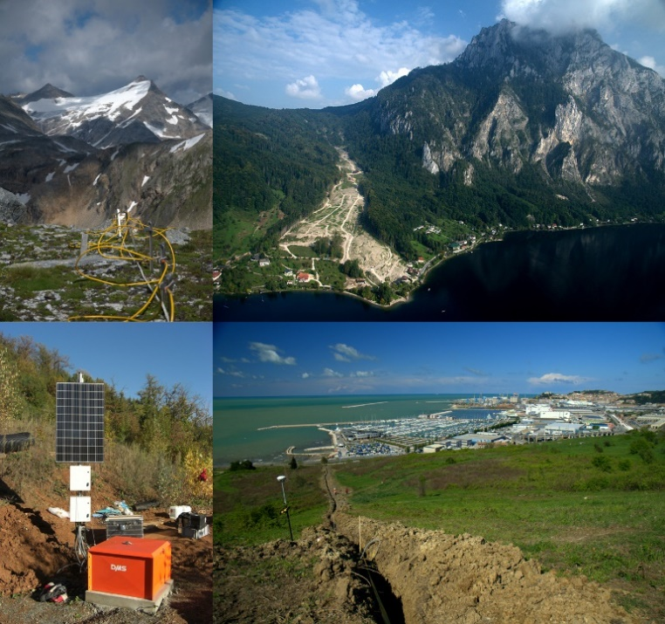
Divide your text into paragraphs as needed.
If you use a figure in your abstract, please write the figure caption at the end of your document like this:
Figure caption: Some nice mountains with snow on top (top left). Great photo. At the photo in the lower right corner you can see the sea. Obviously not in Austria.

